SIMATS ENGINEERING

ASSESSMENT TOOL 2

COURSE NAME: Cryptography and Network Security COURSE CODE: CSA51

COURSE OUTCOME COVERED

CO1: Apply classical encryption techniques using symmetric and asymmetric ciphers to encrypt and decrypt data for the ensuring data security. (BL3, BL4)

Assessment Tool Weightage: 20%

QUESTIONS: 5 Total Marks:50

Annexure A

CONCEPT MAPPING

Code of Conduct:

I (Name / Reg No) certify that this submission is my original work and that I have adhered to the guidelines specified for this assessment.
I understand that any violation of academic integrity rules will result in disciplinary action.

Signature of the student:

Annexure A

CONCEPT MAPPING

- Create a concept map linking the following: Security Attacks, Threats, Risks and Security Goals (Confidentiality, Integrity, Availability. Perform the following tasks:
  - Show how each attack leads to specific threats and risks
  - Map how security goals help mitigate them Provide one real-world example for each link

- Develop a concept map comparing substitution techniques: Caesar Cipher, Monoalphabetic Cipher, Vigenère Cipher and Hill Cipher. Perform the following tasks to connect based on: Key usage, Complexity and Security strength. Analyze which technique is most secure and why.

- Construct a concept map for Classical Encryption Schemes: Substitution Techniques and Transposition Techniques. Perform the following tasks:
  - Show differences and similarities
    - Map how each affects the Data structure and Security level
    - Analyze which is more vulnerable to attacks and why

- Create a concept map connecting Steganography concepts: Data Hiding, Watermarking and Survivability. Perform the following tasks:
  - Show relationships between these concepts
  - Analyze how each contributes to secure communication
  - Include one real-world application for each

- Draw a concept map linking number theory concepts used in cryptography:
Modular Inverse, Extended Euclid Algorithm, Fermat’s Little Theorem, Euler’s Phi Function and Euler’s Theorem. Perform the following tasks:
  - Show how each concept is mathematically connected
  - Map their role in encryption/decryption
  - Analyze which concept is most critical for public key cryptography and justify

RUBRICS FOR CALCULATION:

Criteria | Weighta ge | Level 4 –  Exemplary | Level 3 –  Proficient | Level 2 –  Developing | Level 1 –  Beginning

Understandi ng of Concepts | 25 | Demonstrates thorough understanding and effectively integrates multiple concepts/technolo  gies | Good  understandi ng with  proper integration of most  concepts | Basic understandin g; limited or partial integration | Poor understandin g; unable to integrate concepts
Experiment al Design | 30 | Well-planned, systematic implementation with optimal  solution | Correct implementat ion with  minor issues | Basic  implementati on with errors or inefficiencies | Incorrect or incomplete  implementati on
Use of Tools | 20 | Effective and advanced use of tools/technologies with proper  configuration | Appropriate use of tools with correct execution | Limited or inconsistent use of tools | Incorrect or minimal use of tools
Analysis of Results | 15 | Insightful analysis with accurate interpretation and validation of results | Good analysis with reasonable interpretatio  n | Basic analysis with limited insights | Poor or incorrect analysis of results
Documentat ion | 10 | Clear, well-structured documentation with diagrams,  code, and results | Organized  documentati on with necessary details | Basic documentatio n with missing  details | Poor or incomplete documentatio n

Question 1: Security Attacks, Threats, Risks and Security Goals

A security attack is an action that attempts to compromise information or a system. Every attack gives rise to one or more threats (the potential for harm), which in turn create risks (the likelihood and impact of actual loss). Security goals - Confidentiality, Integrity and Availability (the CIA triad) - are the properties that must be protected, and the corresponding security mechanisms are what mitigate the risks. The concept map below shows this chain: Attack to Threat to Risk to mitigating Security Goal.

Concept Map

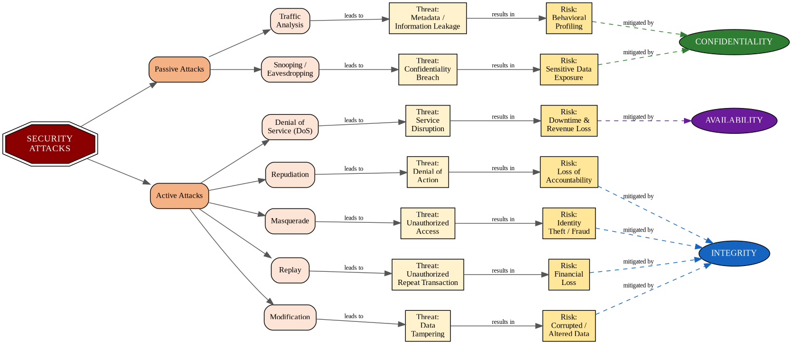

Figure 1: Concept map linking Security Attacks, Threats, Risks and Security Goals (dashed arrows show the mitigating goal).

- How Each Attack Leads to Specific Threats and Risks

Attacks are broadly classified as passive (which only observe communication without altering it) and active (which alter data, streams, or system state). Passive attacks such as snooping and traffic analysis threaten confidentiality by exposing information content or communication patterns, creating the risk of sensitive data exposure or behavioral profiling. Active attacks such as masquerade, replay, modification, denial of service and repudiation threaten integrity, authenticity and availability, creating risks ranging from financial fraud to service downtime. The table below expands every attack-threat-risk-goal link with one real-world example each, as required.

Attack | Threat | Risk | Security Goal | Type | Real-World Example
Snooping / Eavesdropping | Confidentiality breach | Sensitive data exposure | Confidentiality | Passive | An attacker on a public Wi-Fi network captures unencrypted login credentials with a packet sniffer such as Wireshark.
Traffic Analysis | Metadata / information leakage | Behavioral profiling | Confidentiality | Passive | During WWII, observing patterns and volume of encrypted military radio traffic revealed troop movements even without decrypting the messages.
Masquerade | Unauthorized access | Identity theft / fraud | Integrity (with Authentication) | Active | A phishing website impersonates a bank's login page to steal a victim's online-banking credentials.
Replay | Unauthorized repeated transaction | Financial loss | Integrity | Active | An attacker captures a valid funds-transfer packet and resends it later to trigger a duplicate, unauthorized transfer.
Modification | Data tampering | Corrupted / altered data | Integrity | Active | A man-in-the-middle attacker intercepts a bank transfer request and changes the destination account number in transit.
Denial of Service (DoS) | Service disruption | Downtime and revenue loss | Availability | Active | The 2016 Dyn DNS DDoS attack flooded Dyn's servers with traffic, taking down Twitter, Netflix, and other major sites for hours.
Repudiation | Denial of a performed action | Loss of accountability | Integrity (Non-repudiation) | Active | A user who placed a fraudulent online order later denies having done so, and there is no signed log to prove otherwise.

b. How Security Goals Help Mitigate Attacks, Threats and Risks
- Confidentiality is mitigated through encryption, access control and secure channels (e.g., TLS/VPN), which directly counter snooping and traffic analysis by making intercepted data unreadable or the traffic pattern unrevealing.
- Integrity is protected through hashing, digital signatures and message authentication codes (MACs), which detect modification, prevent successful masquerade/replay by binding messages to verified identities and timestamps, and support non-repudiation to counter denial of a performed action.
- Availability is preserved through redundancy, rate limiting, firewalls and DDoS mitigation services (e.g., traffic scrubbing, content delivery networks), which keep systems responsive despite denial-of-service attacks.
In short, every security goal functions as a defensive counterpart to a category of attack: Confidentiality answers passive information-gathering attacks, while Integrity and Availability answer active attacks that alter data or degrade service. A well-designed system layers mechanisms for all three goals because most real incidents combine more than one attack type.

Question 2: Comparing Classical Substitution Techniques

Substitution techniques replace plaintext letters or blocks of letters with other letters, numbers or symbols according to a key. The four classical techniques compared here - Caesar Cipher, Monoalphabetic Cipher, Vigenere Cipher and Hill Cipher - represent an evolution in sophistication, from a single fixed shift to full matrix-based transformation of letter blocks. The concept map below connects each technique to its key usage, complexity and resulting security strength.

Concept Map

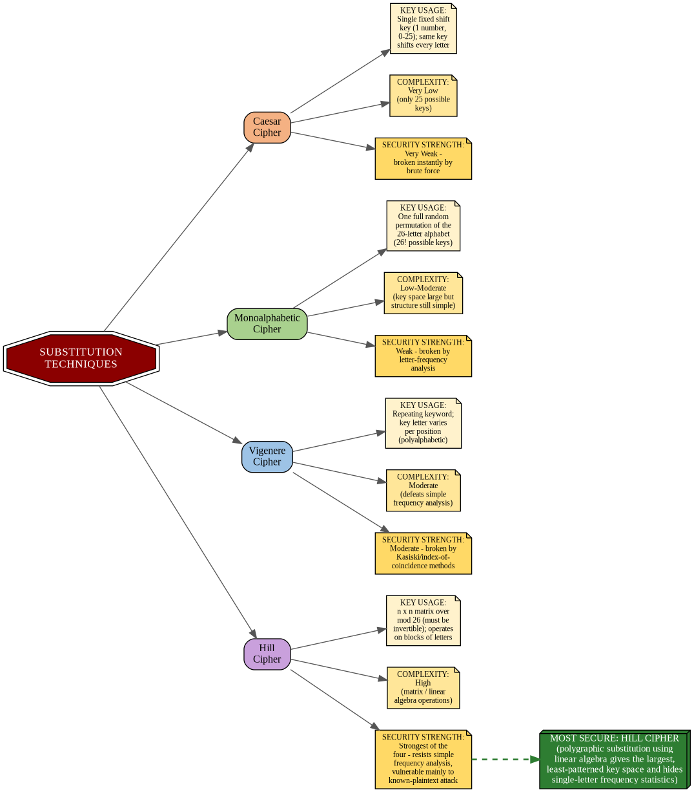

Figure 2: Concept map comparing Caesar, Monoalphabetic, Vigenere and Hill ciphers on Key Usage, Complexity and Security Strength.

Comparison Table

Technique | Key Usage | Complexity | Security Strength
Caesar Cipher | Single fixed numeric shift (1 key, 0-25) applied to every letter | Very low - only 25 possible keys, trivial to brute force | Very weak - broken instantly; no resistance to any form of attack
Monoalphabetic Cipher | One full random permutation of the 26-letter alphabet (26! possible keys) | Low to moderate - huge key space but each plaintext letter always maps to the same ciphertext letter | Weak - frequency analysis of letter occurrence quickly reveals the mapping
Vigenere Cipher | Repeating keyword; the shift changes with position (polyalphabetic) | Moderate - defeats basic single-letter frequency analysis | Moderate - vulnerable to Kasiski examination and index-of-coincidence attacks once key length is found
Hill Cipher | An n x n invertible matrix (mod 26) used to transform blocks of n letters at once | High - requires matrix/linear-algebra operations for encryption, decryption, and key generation | Strongest of the four - hides single-letter frequency statistics; main weakness is vulnerability to known-plaintext attacks
Table 2: Side-by-side comparison of the four substitution techniques.

Analysis: Which Technique Is Most Secure, and Why
Among the four, the Hill Cipher is the most secure classical substitution technique. The reasoning follows directly from the concept map:
- Key space and structure: The Hill Cipher's key is an invertible n x n matrix over mod 26, giving a far larger and more structurally complex key space than a single shift value (Caesar) or even a full alphabet permutation (Monoalphabetic).
- Resistance to frequency analysis: Because Hill Cipher encrypts blocks of n letters together (polygraphic substitution) rather than one letter at a time, it destroys the single-letter frequency statistics that make Caesar and Monoalphabetic ciphers trivially breakable, and it is markedly stronger against classical frequency-based cryptanalysis than the polyalphabetic but still letter-wise Vigenere Cipher.
- Mathematical diffusion: Matrix multiplication spreads the influence of each plaintext letter across multiple ciphertext letters within a block, providing a rudimentary form of diffusion that the other three techniques lack entirely.
The Hill Cipher's main weakness is that it is a linear transformation, so it remains vulnerable to a known-plaintext attack: if an attacker obtains enough matching plaintext-ciphertext block pairs, the key matrix can be recovered using linear algebra. Even so, purely from a ciphertext-only or frequency-analysis standpoint - the main way classical ciphers were historically broken - the Hill Cipher is the strongest of the four, followed by Vigenere, then Monoalphabetic, with Caesar Cipher the weakest by a wide margin.

Rubric Alignment Summary
- Understanding of Concepts: Both concept maps integrate multiple related concepts (attack types, security goals, cipher properties) into a single coherent structure.
- Experimental / Conceptual Design: Each map is systematically organized in layers (cause to effect for Q1; technique to attribute for Q2) rather than a flat list.
- Use of Tools: Diagrams were generated with Graphviz for precise, reproducible concept-map layout.
- Analysis of Results: Each section closes with a written analysis (mitigation strategy for Q1; most-secure justification for Q2).
- Documentation: Diagrams, tables and explanatory text are combined in a single structured Word document.

